ALVIN C. YORK AND WORLD WAR I

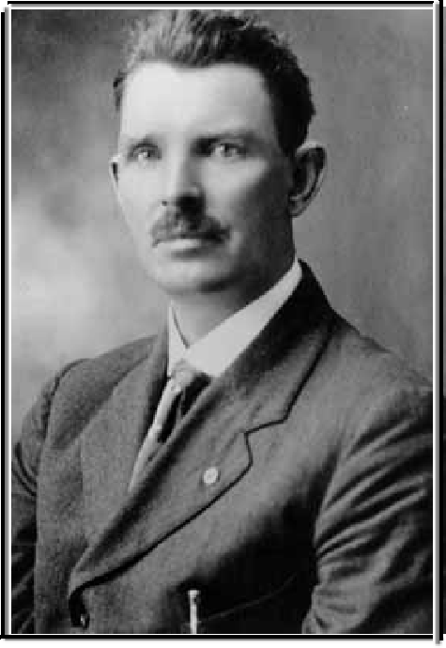

TEACHER’S GUIDE

Prepared by: Lauren W. Grisham

ACKNOWLEDGEMENTS



The *Alvin C. York and World War I Teacher’s Guide* was created in association with the Fentress County Chamber of Commerce by the Center for Historic Preservation at Middle Tennessee State University in Murfreesboro, Tennessee.

The Center for Historic Preservation is a research and public service institute committed to the preservation, protection, enhancement, and sensitive promotion of our historic environment. A Center of Excellence at Middle Tennessee State University, funded by the General Assembly and the University, its primary responsibility is to serve Tennessee’s 95 counties. The Center is recognized nationally and internationally for its innovative approaches, applied experience training, and placement of students. Statewide programs include the following: Tennessee Century Farms Programs, Tennessee Civil War National Heritage Area, Tennessee Rural African-American Church Program, National Register documentation, and Nation Register of Historic Places documentation.

Rural preservation and heritage education are part of many of the Center’s projects.

The Center has dual missions: improving higher education in Tennessee Board of Regents universities and expanding the state’s economic opportunities through historic preservation and heritage development programs and activities. The Center responds to the requests, needs, and concerns of communities, individuals, agencies, and organizations— both governmental and not-for-profit—that are working toward historic preservation goals.

The Center for Historic Preservation supports undergraduate and graduate education and student-centered learning through fellowships, graduate research assistantships, and other employment options.

A special thanks goes to the Fentress County Chamber of Commerce and Historical Society, Alabama Veterans Museum and Archives, Caneta Hankins, Elizabeth Moore, Leslie Sharp, Margaret York, and Melissa

Zimmerman.

**The *Alvin C. York and World War I Teacher’s Guide* may not be reproduced without permission, except for classroom use.**

TABLE OF CONTENTS

Acknowledgments Table of Contents

Biography of Alvin C. York 1-7

Visitor Etiquette 8

A Soldier’s Life: Creative Writing Activity 9

State Matching Game 10

State Matching Game Answer Key 11

Word Search 12

Word Search Answer Key 13

Fentress Finds: Touring Fentress County 14-15

War Poems 16

World War I Matching Game 17

World War I Matching Game Answer Key 18

Victory Gardens 19

Victory Gardens: Answer Key and History 20

Posters With A Purpose 21

Posters With A Purpose Activity 22

The Influenza Pandemic of 1918 23-26

Staying Healthy/Oral History 27

History of Veteran’s Day 28

Cemetery Project 29

Suggested Readings 30

Suggested Websites 31

# BIOGRAPHY OF ALVIN C. YORK

Alvin C. York was born in Pall Mall, Tennessee on December 13, 1887. He would spend all of his life in this area, also known as Valley of the Three Forks of the Wolf, except for the eighteen months he served with the United States Army during World War I. The third son of William and Mary Brooks York, Alvin had seven brothers and three sisters. He received the equivalent of a third-grade education within the community, went to work at his father’s blacksmith shop, and later worked as a farm hand. When Alvin was a young man his father died, and he assumed the role of sole provider for his mother and younger siblings.

During his early years, it was reported that Alvin was considered a bit on the wild side. When the United States entered World War I in April 1917, he was working on a highway construction project for $1.65 a day. It was around this time that a close friend of Alvin’s died. Shortly following, Alvin had a life-changing experience that would set a new tone for his life spawned during a revival conducted by H.H. Russell of the Church of Christ in Christian Union. Alvin began to hold moral conviction against violence and war. He initially considered becoming a conscientious objector when he was drafted. Later he reflected in a speech:

“I loved and trusted old Uncle Sam and I have always believed he did the right thing. But I was worried clean through. I did’nt want to go and kill. I believed in my bible. And it distinctly said *“THOU SHALL NOT KILL.”* And yet old Uncle Sam wanted me.

And he said he wanted me most awfull bad. And I jest didn’t know what to do. I was worried and worried. I couldn’t think of anything else. My thoughts just wouldn’t stay hitched” (Lee, 17).

At Camp Gordon, Georgia, Alvin received permission to take a leave of absence in the mountains for a couple of days to consider the stance he was going to take concerning the war. Upon his return, he determined that he was, in fact, going to be a soldier.

The Battle of Argonne Forest, held on October 8, 1918 in Germany, became another life-altering event for Alvin. It was his extraordinary efforts during this battle that made him an American hero. Alvin was in a seventeen-man detail whose mission was to conquer German machine guns. Nearly single-handedly, he knocked out the German machine gun nests, killed 25 men, captured 132 prisoners, and gathered 35 machine guns. Nine of Alvin’s comrades were injured or killed during this battle, including the sergeant in charge. It is reported that eight Germans were shot with exactly eight rifle shots and a seven-man patrol was killed with his automatic pistol. York summed up the scene by claiming, “Every time I seed a German I jes teched him off.”

In addition, Alvin kept a diary recording his trials and tribulations while at war. The entry for October 8 read:

....there was 17 of us boys went around on the left flank to see if we couldn't put those guns out of action. So when we went around and fell in behind those guns, we first saw two Germans with Red Cross bands on their arms. So we asked them to stop and they did not. So one of the boys shot at them and they run back to our right. So we all run after them, and when we jumped across a little stream of water that was there, they was about 15 or 20 Germans jumped up and threw up their hands and said, 'Kame rad!' So the one in charge of us boys told us not to shoot; they was going to give up anyway.

(These prisoners included a major and two other officers). By this time some of the Germans from on the hill was shooting at us. Well, I was

giving them the best I had, and by this time the Germans had got their machine guns turned around and fired on us. So they killed six and wounded three of us. So that just left 8, and then we got into it right by this time. So we had a hard battle for a little while, and I got hold of the German major and he told me if I wouldn't kill any more of them he would make them quit firing. So I told him all right if he would do it now. So he blew a little whistle and they quit shooting and come down and gave up. I had killed over 20 before the German major said he would make them give up. I covered him with my automatic and told him if he didn't make them stop firing I would take his head off next.

And he knew I meant it. After he blew his whistle, all but one of them came off the hill with their hands up, and just before that one got to me he threw a little hand grenade which burst in the air in front of me. I had to touch him off. The rest surrendered without any more trouble.

There were nearly a 100 of them. We had about 80 or 90 Germans there disarmed, and had another line of Germans to go through to get out. So I called for my men, and one of them answered from behind a big oak tree, and the others were on my right in the brush. (All the non- commissioned officers had been killed or severely wounded except York. This left him in command). So I said, 'Let's get these Germans out of here.' One of my men said, 'It is impossible.' So I said, 'No; let's get them out of here.' So when my man said that, the German major said, 'How many have you got?' And I said that, 'I have got plenty,' and pointed my pistol at him all the time. In this battle I was using a rifle and a .45 Colt automatic. So I lined the Germans up in a line of two's, and I got between the ones in front, and I had the German major before me. So I marched them straight into those other machine guns and I got them. So when I got back to my major's P.C. (post of command) I had 132 prisoners" (qtd. in Alvin C. York Biography).

On November 10, 1918, only ten days before the war ended, Alvin was promoted to sergeant. Then on April 11, 1919, he received the Congressional Medal of Honor. During the time of his death, Alvin received over fifty war decorations. On May 10, 1919, Alvin began his journey back home to Pall Mall, Tennessee.

He boarded the U.S.S. Ohio in Bordeaux, France, crossed the Atlantic Ocean, and landed in Hoboken, New Jersey on May 22. At the port, he was met by the Tennessee Society in New York City and taken into New York City. They gave him a

hero’s welcome and a ticker-tape parade. Although Alvin was very grateful, he wrote, “I wanted to get back to my people where I belonged and the little old mother and the little mountain girl who were waiting” (qtd. in Alvin C. York Biography).

One week and one day after his return, Alvin and his “little mountain girl,” Gracie Williams, were married in a ceremony performed by the Governor of Tennessee, A.H. Roberts. After a two day honeymoon in Nashville, they moved onto a 385-acre farm which grateful Tennesseans had helped purchase.

However, the peaceful valley Alvin called home was not the same upon his return. People came from all over the country in order to meet him and to offer him business propositions, ranging from Broadway and Hollywood producers to advertisers wanting to commercialize and profit from his war efforts. He wrote at this time:

I knew if I hadn’t been to war and hadn’t been a doughboy they never would have offered me anything. I also knew I didn’t go to war to make a heap or to go on the stage or in the movies. I went over there to help make peace. And there was peace now, so I didn’t take their thirty pieces of silver and betray that there old uniform of mine. I just wanted to be left alone to go back to my beginnings. The war was over. I had done my job and I had done it the best I could. So I figured I ought to be left alone and allowed to go back to the mountains where I belonged (qtd. in Alvin C. York Biography).

A changed person, he realized the need for improved education in his secluded hometown community and decided to dedicate himself to improving educational opportunities. Alvin wrote:

I knew I wasn’t like I used to be. The big outside world I had been in and the things I had fought through had touched me up inside a powerful lot… I was sort of restless and full of dreams and wanted to be

doing something and I didn’t understand. So I sat out on the hillside trying to puzzle it out. Before the war I felt the mountains isolated us and kept us together as a God-fearing, God-loving people. They did that, too, but they did more than that. They kept out many of the good and worthwhile things like good roads, school, libraries, up-to- date homes and modern farming methods (qtd. in Alvin C. York Biography).

During the 1920s, York went on speaking tours in order to call attention to his mission for educational improvements for children in rural Fentress County, and to raise money for a school, the York Institute. Alvin also showed an interest in politics in order to obtain funding for better roads, local employment opportunities, and for education. During the presidential election of 1932, he changed his political party in order to support Herbert Hoover and to protest Franklin D. Roosevelt’s promise to repeal prohibition. Once seeing the effects of the New Deal however, Alvin decided to support the president’s relief efforts. In 1939, he was elected superintendent of the Cumberland Homesteads near Crossville.

Originally named the York Industrial Institute, the York Agricultural and Industrial Institute was a reflection of Alvin’s vision to educate the youth in rural Fentress County, which did not happen easily. Located in the city of Jamestown, the school’s mission was to train its students for a technological future.

In 1925, the Tennessee General Assembly set aside $50,000 for the school’s construction. Alvin, a Democrat, was at odds with the local Republican county executives over where the school should be located.

When the local officials threatened eviction from the site in 1927, he went directly to the state legislature and turned to the media for support. As a result, the Tennessee Department of Education was given control over the York Institute.

The school officially opened in 1929, but even with the state’s backing, was under funded. Fentress County refused to give the school any funding. Alvin mortgaged his house twice to pay teachers’ salaries, paying them out of his own pocket. He even purchased school buses. Although the investigation ultimately uncovered no wrong doings, Alvin faced charges by the Department of Education for incompetence, negligence, nepotism, and bringing in outsiders in 1933.

Many felt that this was an accusation brought on by York’s antagonists. Regardless, Alvin was unable to continue funding the school the way he had been.

Alvin was appointed President Emeritus and led the school’s ceremonial activities. With this change of administration, the Department of Education required that all teachers have a bachelor’s degree, along with other mandatory criteria.

Today, the York Institute is the only state-owned and operated high school in Tennessee. It is also one of the largest high schools in the world, encompassing over 14,000 acres. The original York Institute building is listed on the National Register of Historic Places.

Hollywood filmmaker Jesse L. Lasky struggled with Alvin for ten years before he agreed to let Lasky create the film, “Sergeant York.” When Alvin finally agreed to meet about the possibility of a film, he was getting ready to open an interdenominational bible school. The school was intended to compliment the preexisting York Agricultural Institute. Despite a twenty-year stance he had taken on not profiting off his war efforts, “Sergeant York” presented a financial opportunity to back his school. After much negotiation, Alvin settled on the movie contract in return

for fifty thousand dollars plus two percent of the gross sales. Lasky emphasized the fact that this was not a “war movie” that glorified war—a style of movie both Lasky and Alvin disliked. The film opened July 2 at the Astor Theater. “Sergeant York” gained much commercial success, rejuvenating Lasky’s career. Gary Cooper, who portrayed Alvin in the film, won an Academy Award for Best Actor.

In 1951, the IRS accused him of tax evasion from movie profits given to the school. Alvin spent ten years working this out with Speaker of the U.S. House of Representatives Sam Rayburn and Congressman Joe L. Evins. Additionally, citizens nationwide came to his aide with a York relief fund.

This committee of concerned citizens not only helped Alvin reach a settlement with the IRS, but a trust fund was established. In the midst of this turmoil, York suffered a stroke in 1954 that left him bedridden until his death on September 2, 1964. Alvin C. York was buried with full military honors in Wolf River Methodist Church Cemetery. An estimated 7,000 people attended his funeral.

# VISITOR ETIQUETTE

When visiting a museum or historic site, such as the Alvin C. York home, there are certain rules that should be followed. Please remind students of these basic rules.

Additionally, call the site before visiting to schedule a group visit and to determine if there are any special rules that need to be considered.

1. Remember that items in a museum are not only historic and often fragile, but are also very meaningful to the community. Be careful not to touch items, including the walls and furnishings.
2. Do not bring food, drinks, or chewing gum inside. If you wish to eat on the grounds, call ahead to ensure that you have permission to do so and make sure to dispose of trash properly. A good rule of thumb is to leave the site cleaner than you found it.
3. No running or horseplay. Stay with your group.
4. Be mindful of fellow students so everyone can hear, learn and have a good time.
5. Students should use inside voices and, better yet, raise their hands if they have a
6. question or comment.
7. Please arrive on time. Tardiness may deduct from your visit time.
8. Be sure to ask permission before taking photographs or videotaping.
9. Have fun learning!

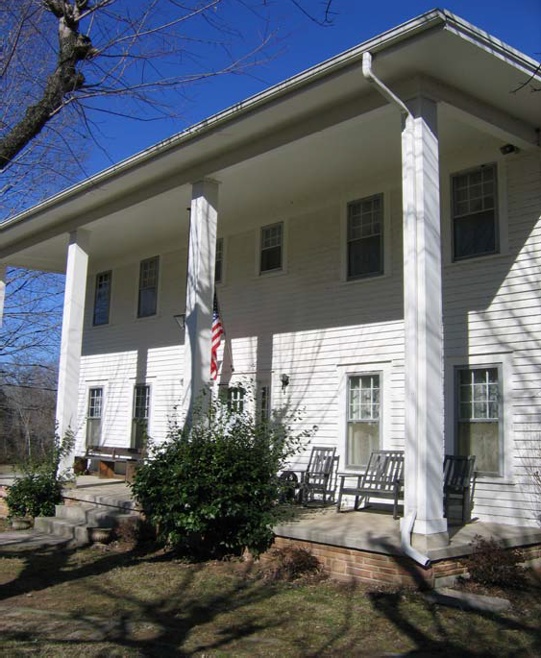

# A Soldier’s Life: Creative Writing Activity





Imagine this World War I soldier is one of your ancestors. Create a story that explains what his life was like before the war, during the war, and afterwards.

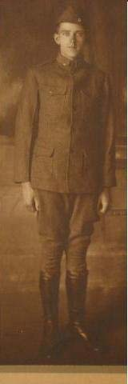

Here are a couple of questions to get you started!

1. Where did this World War I soldier live before he went to war?
2. How do you think he felt when he realized he was going to war? Do you think he was a conscientious objector who was drafted like Alvin C. York or do you think he signed up to go?
3. What kind of life do you think he left behind? Did he have a wife or children? How do you think they felt when they found out he was going to war?
4. Where was he stationed in the war?
5. What kind of feelings do you think he had while he was overseas at war?
6. If this soldier wrote a letter home, what would it say?
7. How do you think his friends and family reacted upon his arrival home?
8. What do you think his opinions were towards World War I?

CPL Landon Fuller. Company C, 30th Old Hickory Division. 105th Supply Train.

Photo taken in 1919. From the Collection of the Arts Center of Cannon County.

105th Supply Train. From the collection of the Arts Center of Cannon County.

# STATE MATCHING GAME

DIRECTIONS: Draw a line matching the statement to the correct state.

This is where Alvin received his hero’s welcome and

a ticker tape parade

The capital of the United States

The home state of President Woodrow Wilson

1

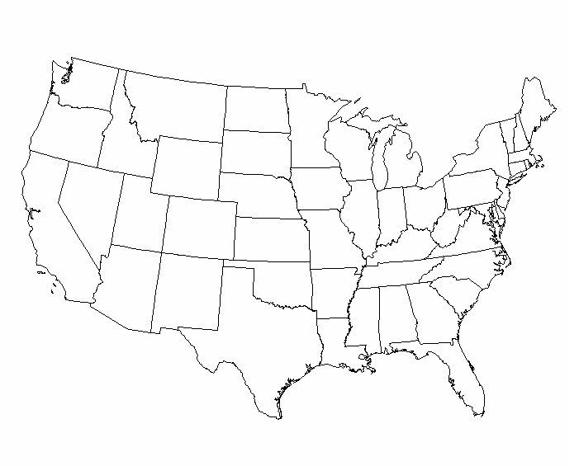

The state where Camp Gordon and Fort Oglethorpe are located

The state where Alvin’s ship left for England

The home state of Alvin C. York and Gracie

Williams York 10

STATE MATCHING GAME ANSWER KEY

DIRECTIONS: Draw a line matching the statement to the correct state.

This is where Alvin received his Hero’s Welcome and a Ticker Tape Parade

(NEW YORK)

The capital of the United States (WASHINGTON D.C.)

The home state of President Woodrow Wilson (VIRGINIA)



The state where Camp Gordon and Fort Oglethorpe are located

(GEORGIA)

The first state where Alvin arrived upon returning from service (NEW JERSEY)

The state where Alvin’s ship left for England (MASSACHUSETTS)

The home state of Alvin C. York and Gracie

Williams York. (TENNESSEE)

11

ALVIN C. YORK WORD SEARCH

|  |  |  |  |  |  |  |  |  |  |  |  |  |  |  |
| --- | --- | --- | --- | --- | --- | --- | --- | --- | --- | --- | --- | --- | --- | --- |
| G  R | Z  S | U  B | S  H | S  M | O  I | H  F | I  A | O  L | T  F | P  A | S  M | G  R | M  K | A  R |
| A | E | U | H | O | H | E | R | O | T | L | B | E | G | P |
| C | R | I | O | U | T | N | L | M | G | L | O | W | E | B |
| I | G | N | B | N | D | T | F | A | R | M | E | R | R | O |
| E | E | S | O | T | N | R | O | L | N | A | N | E | M | R |
| P | A | I | K | A | N | E | A | N | T | L | Y | V | A | D |
| U | N | D | E | I | V | S | D | M | A | L | V | I | N | E |
| E | T | E | N | N | E | S | S | E | E | S | Y | L | Y | A |
| Y | Q | J | B | S | A | W | O | P | A | Y | U | L | O | U |
| A | R | G | O | N | N | E | F | O | R | E | S | T | R | X |
| R | W | C | A | M | P | G | O | R | D | O | N | R | U | I |

|  |  |  |  |
| --- | --- | --- | --- |
| Alvin | Fentress | Tennessee |  |
| Gracie | Argonne Forest | Farmer |  |
| Mountains | Germany | Sergeant |  |
| Pall Mall | USS Ohio | Hero |  |
| Camp Gordon | Hoboken | Bordeaux | 12 |

ALVIN C. YORK WORD SEARCH *ANSWER KEY*

|  |  |  |  |  |  |  |  |  |  |  |  |  |  |  |
| --- | --- | --- | --- | --- | --- | --- | --- | --- | --- | --- | --- | --- | --- | --- |
| G | Z | U | S | S | O | H | I | O | T | P | S | G | M | A |
| R | S | B | H | M | I | F | A | L | F | A | M | R | K | R |
| A | E | U | H | O | H | E | R | O | T | L | B | E | G | P |
| C | R | I | O | U | T | N | L | M | G | L | O | W | E | B |
| I | G | N | B | N | D | T | F | A | R | M | E | R | R | O |
| E | E | S | O | T | N | R | O | L | N | A | N | E | M | R |
| P | A | I | K | A | N | E | A | N | T | L | Y | V | A | D |
| U | N | D | E | I | V | S | D | M | A | L | V | I | N | E |
| E | T | E | N | N | E | S | S | E | E | S | Y | L | Y | A |
| Y | Q | J | B | S | A | W | O | P | A | Y | U | L | O | U |
| A | R | G | O | N | N | E | F | O | R | E | S | T | R | X |
| R | W | C | A | M | P | G | O | R | D | O | N | R | U | I |

Alvin Fentress Tennessee

Gracie Argonne Forest Farmer Mountains Germany Sergeant

Pall Mall USS Ohio Hero

Camp Gordon Hoboken Bordeaux

13

*FENTRESS FINDS…*



TOURING FENTRESS COUNTY

First stop: **Ye Ole Jail Historic Museum**

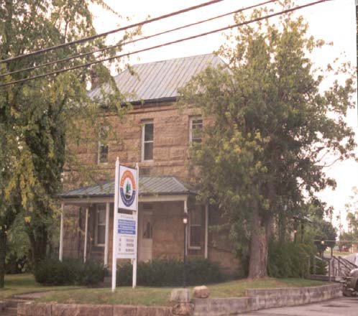

The jail, built from stone quarried locally, was completed in 1898. It was built from stone native to the area. Costing

$6,000 to build, it was considered an excellent facility. It was placed on the National Register of Historic Places in 1984 and is now the home of the Fentress County Chamber of Commerce and a museum. The museum features artifacts from the time the building was used as a jail.

Second stop: **Gristmill**

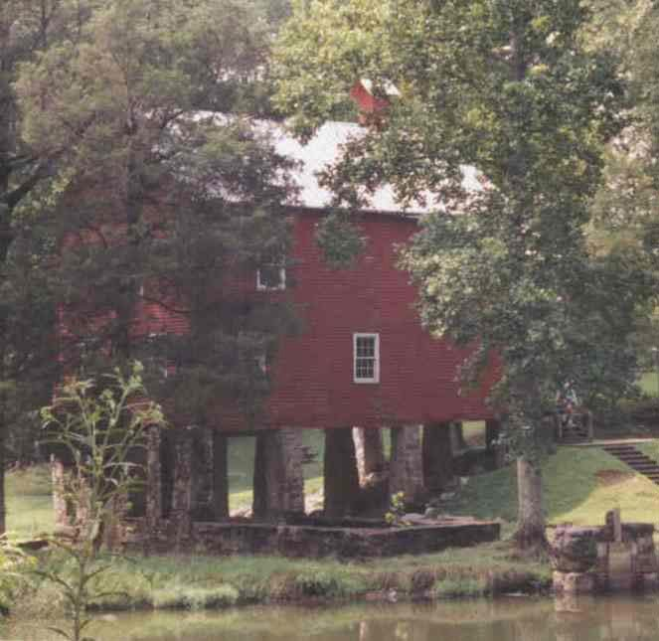

This gristmill is part of the Alvin

C. York Historic Site at Pall Mall. Sergeant York operated the gristmill during the 1940s. Gristmills were once found in almost every community and pro- duced flour from wheat and meal from corn. Sheltered picnic tables are available for visitors, overlooking the Wolf River.

14

Third stop: **Alvin C. York State Historic Site**

The Alvin C. York State Historic Site features York’s Colonial Revival home built in 1921. York and his wife Gracie moved to the home after they wed, and lived the remain- der of their lives here. The home features furnishings, decorations, and mementos original to the York family.

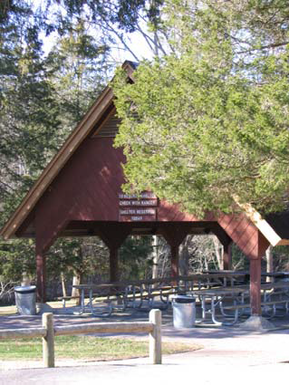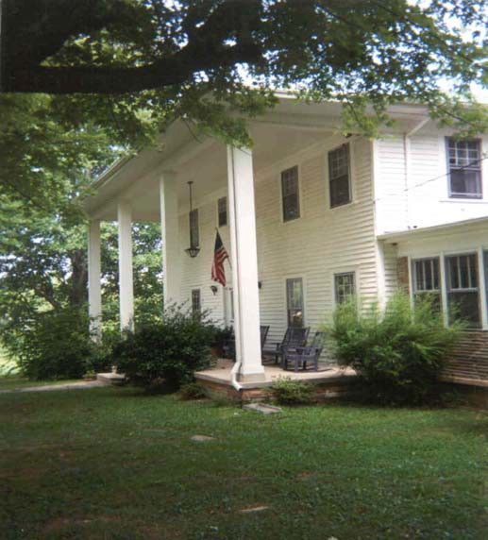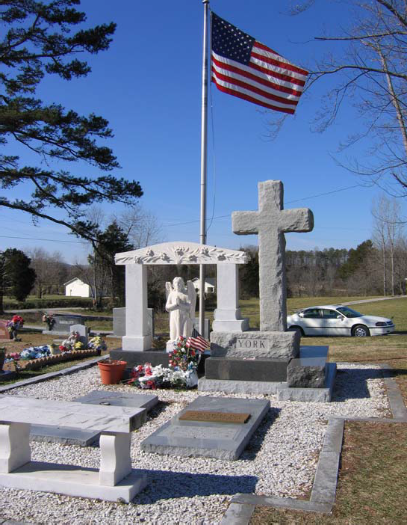

Last Stop: **York Burial Site**

Located near the Alvin C. York State Historic Site. Alvin and Gracie are buried here, as are several other family members.

15

# WAR POEMS

May Sinclair was born in England in 1863. She went to a college for women, where she pursued her interests in Greek literature, philosophy, and psychology. She supported herself by writing poems, articles about philosophy, and short stories. During World War I, Sinclair was one of the first women to serve with the Red Cross in the Belgian Field Ambulance Corps. Her poem, “Field Ambulance in Retreat”, is what is called an *eyewitness poem*, or a poem that was written while the event was actually happening.

*The road-makers made it well*

*Of fine stone, strong for the feet of the oxen and of the great Flemish horses, And for the high wagons piled with corn from the harvest.*

*And the laborers are few;*

*They and their quiet oxen stand aside and wait*

*By the long road loud with the passing of the guns, the rush of armored cars and the tramp of an army on the march*

*forward to battle;*

*And, where the piled corn-wagons went, our dripping Ambulance carries home Its red and white harvest from the fields.*

After reading the excerpt from the poem, consider then answer the questions below.



* 1. What was Sinclair talking about in her poem “Field Ambulance in Retreat”?
  2. What was the “red and white harvest from the fields?”
  3. How does this poem make you feel? Why?
  4. Try your hand at writing your own

eye-witness poem about a place you have been or something you have done.

16

MATCHING GAME: WORLD WAR I SLANG

Match the word with what you assume is the correct definition of the slang term.

What was the name given to souvenirs collected from the battlefield, often from the bodies of dead soldiers?

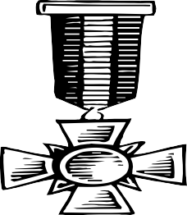

What was the nick- name given to high ranking Army offi- cers?

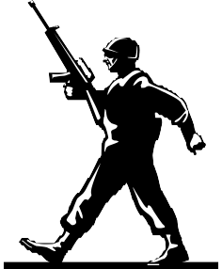

What did soldiers call cooking pots?



CHATTING

CURIO

BRASS HELMET

MATCHING GAME:

WORLD WAR I SLANG ANSWER KEY

Match the word with what you assume is the correct definition of the slang term.

What was the name given to souvenirs collected from the battlefield, often from the bodies of dead soldiers?



What was the nick- name given to high ranking Army officers?



What did soldiers call cooking pots?



What was the act of removing lice from one’s clothing?

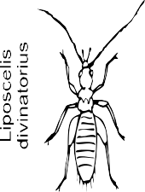

DIXIE

CURIO

BRASS HAT

CHATTING

# VICTORY GARDENS

Because of food shortages overseas, President Wilson encouraged the citizens of the United States to plant gardens in order to grow their own food. These gardens planted in order to contribute to the war effort quickly became know as *Victory gardens.* It was esti- mated that thousands—possibly even

*millions* of people were growing victory gardens in their front and back yards and in some cases, on their roof tops! This war effort included children, too. Newspaper editorials stated, “Encourage the younger boys and girls to work in your Victory Garden!” The popularity of victory gardens grew so quickly, that newspapers were soon full of advertisements for seeds, fertilizers, and garden tools often with a patriotic slogan One read,

“The Hoe Behind the flag, Plant a Victory Garden!”



1. If you were going to plant a victory garden, what would you plant? List at least 3 plants.
2. How did you think victory gardens contribute to the war effort during World War I?
3. What can you do today to help your country?





# Victory Gardens Answer Key and History

HISTORY

Germany’s submarine warfare severely hurt Great Britain’s food supply because most of their food was moved by submarines. At one time, Ambassador Page reported that Britain only had enough food for six more weeks. Another time, Lord

Rhondda, England’s Food Controller, heard a (false) rumor that all of the grain in America was running out and said, “We are beaten, the war is over!” President Wilson’s request for Americans to plant gardens was urgent the country was suffering from a lack of farm workers with so many men fighting the war., and Europe and America needed more food.

1. Some of the vegetables and fruits that were planted in victory gardens included: beans, beets, carrots, peas, radish, lettuce, spinach, chard, onions, cucumbers, parsley, kohlrabi, squash, corn, parsnips, leeks, turnips, cabbage, brussels sprouts, broccoli, peppers, cauliflower, tomatoes, eggplant, endive, and rutabagas. *(Project idea: Have the students draw their ideal victory garden or create a miniature one in an egg crate. Also, if there is a vegetable they are unfamiliar with, have them research it. What does it look like?, What does it taste like?, Where is it grown?, What is a recipe it’s used in?)*
2. Victory gardens helped contribute to the war effort by making citizens more self- reliant for food because they were growing their own. As a result, there was more food avail- able to send to the soldiers abroad.
3. During the times of war, some things that are done on the home front include: putting the yellow ribbons on cars to show support for the troops; conserving gas by Carpooling, buying a more fuel-efficient car, and walking and/or riding your bike places

instead of driving; and writing soldiers letters and sending them care packages abroad, etc. Other general ideas for helping the country might include: recycling to conserve the earth’s resources, never littering, and donating clothes and toys to your local shelter.

  

# POSTERS WITH A PURPOSE

Artist: John E. Sheridan, 1918?

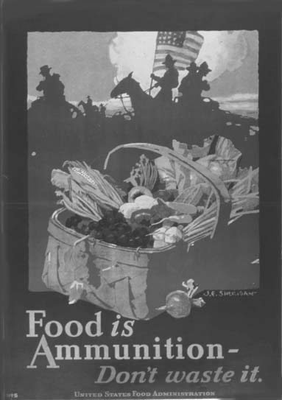

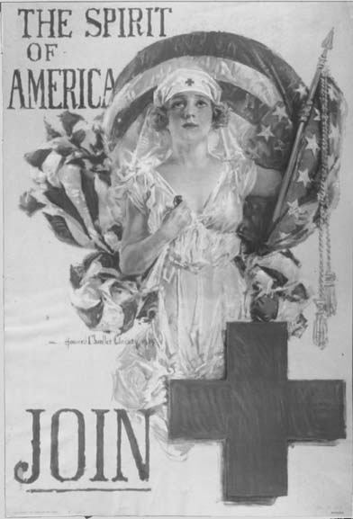

The images above are examples of war posters that were used during World War I. A large amount of these posters were printed and posted throughout the country. Many artists offered their talents for free in order to support the war effort. War posters encouraged both recruitment in the military and individual efforts on the home front, such as planting victory gardens, buying liberty bonds, or joining the American Red Cross.

Artist: Howard Chandler Christy, 1918?

# POSTERS WITH A PURPOSE ACTIVITY

Create your own poster. Remember what you learned about the purpose of war posters in order to create your own. Pick one of the following themes:

1. Encourage citizens to plant a Victory garden so more food can be sent to soldiers.
2. Show the importance of recycling materials, like aluminum cans in order to conserve.
3. Promote alternatives to driving a car and using so much gasoline, such as riding a bike



22

# The Influenza Pandemic of 1918

The beginning of 1918 was a spirited time in the United States. Patriotism was running high, and the United States was helping to win the war in Europe. Little did anyone know that a medical battle lay ahead on the home front and abroad that would bring devastation, disease, and death, an illness that if were to happen today would kill more than 1.5 million Americans. By the time the outbreak ended in 1918, over 550,000 Americans had died in just ten months.

No one really knows where the virus came from. Early on, it was referred to as the “Spanish Influenza.” In February o f 1918, the tourist season in the Spanish town of San Sebastian was in full force. This was a place where tourists could come and avoid talks of war… a place to relax. When influenza came to town, surprisingly targeting young adults ages 21-29. Town officials tried to keep word of the illness quiet, but that did not work. San Sebastian was a place to be avoided. Soldiers in Europe were getting sick, too. No one could trace the pattern of how the disease was spreading. . By April, eight million citizens of Spain had the virus, including King Alfonso XIII. Some theorized that the virus spread throughout Europe and the world from Spain.

Another theory suggested that the virus started at Fort Riley in Kansas. Soldiers stayed in an area not far from pig farms. They would burn manure when cleaning up and clearing land. The huge black clouds of smoke resulting from the burning manure is what was claimed to spread the virus. Flu experts, however, concluded the virus could not

be spread this way.

Only twenty percent of the flu victims recovered. This particular strain was stronger than any of the influenza viruses carried today and was comparable to the Black Plague.

Victims experienced two different types of symptoms. Some nearly immediately experienced pneumonia, their lungs filling up with fluid. Many could hardly breathe, causing them to drown from the fluid. Some took days to die, some hours. While they were sick, they experienced a high fever that caused them to “lose their mind.” Next, they would experience lack of air, and finally they would drift into unconsciousness.

Others experienced more typical flu symptoms—chills, fever, and muscle aches. By the fourth or fifth day. They developed pneumonia which either killed them or left them with a long recovery period.

Although the nation was quickly becoming infected, there was still a war to fight. President Woodrow Wilson (who was reported to have had influenza and recovered) made the decision to begin drafting soldiers. These soldiers traveled in such close conditions that many became ill. A virus spreads through the air, meaning one only has to breathe in germs to become infected.

Because of the focus on the war overseas, officials initially failed to see influenza as a serious threat. It went largely underreported. Also, so many families were in despair from losing their loved ones that many denied the spread of influenza was happening at all.

It was as if they wanted this disaster to be erased from their memories forever.

Deaths were happening so quickly that there were not enough caskets or gravediggers. Some people even stole caskets for their lost loved ones. Due to the shortage of gravediggers, many bodies were placed in mass graves, because there was not enough time to bury each body individually. Many flu victims did not receive a proper burial, and family and friends were left unable to mourn as they would have normally. Some families were even forced to place victims’ bodies outside of the house to be picked up to avoid leaving the contaminated body in the house for any length of time.

Scientists worked around the clock trying to make a vaccine that would protect the people from further contamination. However, due to the lack of technology they had, the scientists could not make the vaccine because they could not tell under the microscope what exactly they were vaccinating against. The virus was too small to see under the microscope they had at the time. Many cities health banned public gatherings, including church services, funerals, and schools in order to prevent the virus from spreading further.

For a while, paper masks were thought to be the solution. There are pictures of baseball games where everyone in the crowd and all of the ball players were wearing them. However, this precaution was not enough to stop the spread of disease, because the masks were paper, and therefore, porous. The paper masks could not block the germs. Someone compared the masks to “keeping out dust with chicken wire”.

With nothing available to stop the virus, people turned to folk remedies. One folk remedy suggested putting a small amount of kerosene on sugar, then eating it!

Can you imaging the smell and taste?

The virus spread so quickly that there were not enough hospital beds or enough people to work in the hospitals. Many doctors and nurses had been sent to Europe to support the war effort, leaving the hospitals under-staffed. One report listed one nurse for every forty-two beds. Camps were set up in parks and playgrounds to serve as temporary emergency relief centers.

October of 1918 proved to be the nation’s deadliest month, with over 195,000 Americans succumbing to the influenza pandemic. Fortunately, it left as quickly as it came. The influenza had killed 550,000 Americans in ten months, and 30 million world wide.

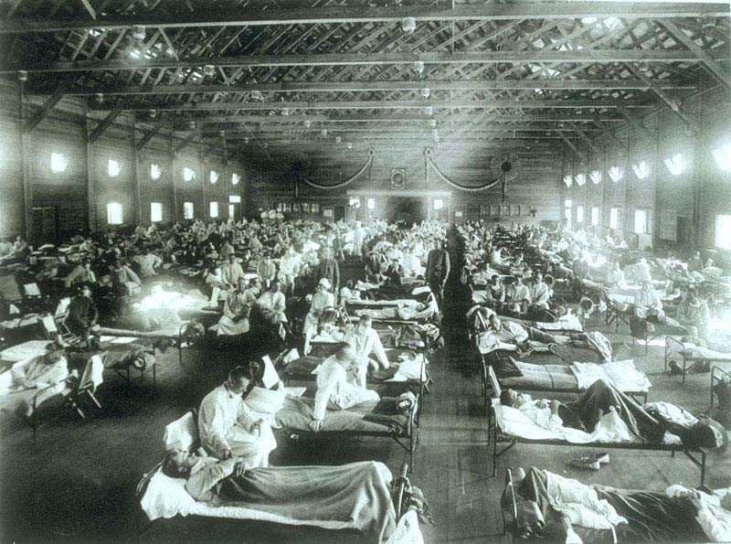

Courtesy of the National Museum of Health and Medicine, Armed Forces Institute of Pathology, Washington, D.C. NCP 1603.

Photograph of an emergency hospital during the flu pandemic, Camp Fulston, Kansas.

. 25

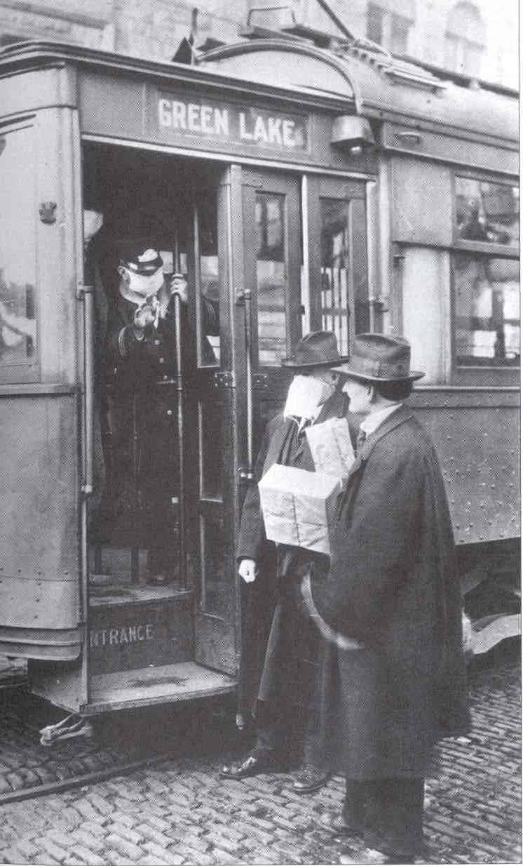

Courtesy of the National Archives at College Park, MD. Record Number 165-WW-269B-11.

mask.

To the left, a man is denied entry on a Seattle street car for not wearing a paper

26

STAYING HEALTHY

Here are some precautions you should take year round, especially during the flu season!



* 1. Wash your hands frequently, especially after sneezing or coughing, handling money, opening or closing a door, and before eating.
  2. Whenever you sneeze or cough, cover your mouth and nose.
  3. If you are sick, stay at home to avoid infecting others.
  4. Talk to your doctor to make sure your vaccinations are up to date.



* 1. Eat healthy and exercise regularly to build up your immune system and maintain a healthy body.



ORAL

HISTORY

Oral history is historical information gathered through interviews with people who experienced an even first-hand. Most historians use voice recorders or video tape during the interview process. Ask your grandparents or an older person from you neighborhood or church about what illnesses were around when they were young. Some questions you might ask: “Did you know anyone who have a very bad case of the flu?”, “Do you know of any cures that you can make yourself for illnesses?”, and/or “Do you know any precautions your town took in order to keep illnesses from spreading?” Come up with some of your own ques- tions. Be very polite and remember, some of your interviewees may not want to talk about it.

 27



# HISTORY OF VETERAN’S DAY

Veteran’s Day is a national holiday observed on November 11. The origin of Veteran’s Day dates back to World War I. World War I officially ended on **June 28, 1919** following the signing of the **Treaty of Versailles**, in which Germany responsibility for the war and also was charged **reparations**.

While the treaty was not signed until the summer of 1919, these were costs due to the actual fighting between the allies and Germany ended with an **armistice** on the **eleventh hour of the eleventh day of the eleventh month on 1918**. An armistice is a truce between parties at war. Originally known as Armistice Day, November 11 officially became a holiday in 1926.In 1954, it’s name was changed to Veteran’s Day in order to honor

*all* United States veterans.

Official Veteran’s Day ceremonies take place at the Tomb of the

Unknowns, located in Arlington National Cemetery, near Washington D.C. In honor

of all United States soldiers past and present, a **vigil** is kept all day and night by the Third United States Infantry. A vigil is a gathering of people over an extended period of time, usually to memory of the person who has died. Another ceremony that takes place at the Tomb of the Unknowns is the “presentation of arms” by color guards from each branch of the armed forces, followed by the laying of the presidential wreath. “Taps” is played in honor the fallen soldiers.

Taps is unique to the U.S. military and is used at funerals and wreath-laying and memorials services. There are varying opinions on how Taps originated. A story that everyone seems to agree on is that is was derived from a “Extinguish Lights” songs—an song used to notify soldiers it was time for “lights out.” The first recorded use of Taps at a funeral occurred in 1862. Captain John C. Tidball of Battery A, Second Artillery ordered to be played at a funeral of a cannoneer killed in action. There are no official lyrics to the Music, but some of the most popular verses are listed below.

“Day is done, gone the sun, From the hills, from the lake, From the sky. All is well, safely rest, God is nigh. Go to sleep, peaceful sleep, May the soldier or sailor, God keep. On the land or in the deep, Safe in sleep. Love, good night, Must thou go, When the day, And the night Need thee so? All is well. Speedeth all To their rest. Fades the light; And afar Goeth day, And the stars Shineth bright, Fare thee well; Day has gone, Night is on. Thanks and praise, For our days, ‘Neath the sun, Neath the stars, ‘Neath the sky, As we go, This we know, God is nigh.”

# Cemetery Project

For this project, you will need to go to a local cemetery (make sure you bring an adult along with you). Cemeteries can tell you a lot about the history of your community. Visit and look for burials from before 1930. Observe the birth and death dates and the tombstone de- signs. See if there are a lot of tombstones with the year of death being 1918. Do you think they died from the flu pandemic? Was the person a soldier? If there are tombstones with a design on them that you find interesting, you can do a **r*ubbing****.* For this, you will need crayons, plain white paper, and masking tape.



  

1. Before you begin, always check with the cemetery commissioner, historical society, or town clerk, and make sure that rubbings are allowed in the cemetery.
2. Make sure the tombstone is in good condition. Look for cracks and evidence of repair, to see if it is too fragile. If it looks “broken”, don’t do it!
3. Use your paper to cover the entire stone, and secure it with masking tape. Do ***not*** use scotch or duct tape.
4. Test the paper and color before you begin to make sure no color “bleeds” through.
5. With your crayon on its side, rub gently, slowly, and carefully. The design will show on your paper.
6. Do ***not*** leave any trash. When you are finished, try to leave the site cleaner than you found it.
7. If you run across symbols (like animals, hands, flowers, etc.) on the tombstones, there are several books and internet sites you can look at to determine the meaning.

SUGGESTED READINGS

Cowan, Sam K. Sergeant York and His People. Jamestown, TN: Fentress County Publishing (Fentress County Historical Society), n.d.

Early, Francis H. A World Without War. Syracuse: Syracuse University Press, 1997. Fleming, D.F. The Origins and Legacies of World War I. Garden City: Doubleday &

Company, Inc., 1968.

Kennedy, David M. Over Here. New York: Oxford University Press, 1980.

Kolata, Gina. Flu: The Story of the Great Influenza Pandemic of 1918 and the Search for the Virus That Caused It. New York: Farrar, Straus, and Giroux, 1999.

Lee, David D. Sergeant York. Lexington: University of Kentucky Press, 1985.

Pendergast, Sara and Tom Pendergast. World War I Primary Sources. Detriot: UXL, 2002. Trask, David F. World War I at Home. New York: John Wiley & Sons, Inc., 1970.

# SUGGESTED WEBSITES

*Websites listed below are subject to change and should be used with discretion.*

## ALVIN C. YORK SITES

Alvin C. York <http://www.alvincyork.org/>

York Home <http://www2.york.k12.tn.us/>

The Diary of Alvin C. York <http://acacia.pair.com/Acacia.Vignettes/>

The.Diary.of.Alvin.York.html

Tracing Sgt. York (The Tennessean*)* <http://www.tennessean.com/apps/pbcs.dll/>

article?AID=2006603240384

ADDITIONAL SITES

American Memory <http://memory.loc.gov/ammem/fsahtml/> fahome.html

The Association for Gravestone Studies <http://www.gravestonestudies.org/index.htm> First World War.com <http://www.firstworldwar.com/index.htm>

National Museum of Health and Medicine

<http://nmhm.washingtondc.museum/>

The Heritage Education Network <http://histpres.mtsu.edu/then/index.html>

The Tennessee Encyclopedia of History and Culture

<http://tennesseeencyclopedia.net/>

U.S. National Archives and Records Administration (NARA)

<http://www.archives.gov/>