Andrew Johnson’s Impeachment
Standards: 5.22
The links below contain a variety of sources and activities related to the impeachment of Andrew Johnson.
Vote to Impeach Andrew Johnson from America’s Library
http://www.americaslibrary.gov/jb/recon/jb_recon_impeach_1.html
The Impeachment of Andrew Johnson by NPS.gov
http://www.nps.gov/anjo/historyculture/impeachment.htm
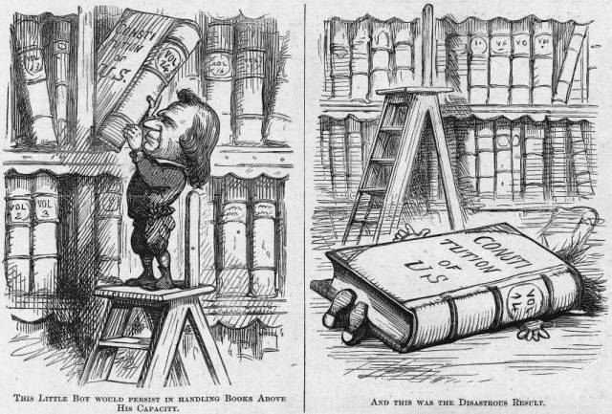

Political Cartoon of Johnson’s impeachment
http://law2.umkc.edu/faculty/projects/ftrials/impeach/Cartoon-Constit.jpg

