Anthony Burns and the Fugitive Slave Act Activity
Standards: 4.67, 8.67
Background
ANTHONY BURNS: FUGITIVE SLAVE
Burns was born a slave in Stafford County, Virginia on May 31, 1834. He was the thirteenth and last child of the family cook of John Suttle and of her third husband, who supervised other slaves working in a stone quarry. After Suttle and his wife died, Burns became the property of their eldest son, Charles Suttle, a merchant who eventually moved to Alexandria. Burns remained with his mother in Stafford County and learned to read and write. He joined the Baptist Church and may have preached, which would have been a violation of Virginia law. As an adult, Burns was about six feet tall with a dark complexion and scars on his cheek and right hand.
Suttle hired his slaves out to various men in Stafford County, and Burns worked for a time for William Brent, of Falmouth. In 1852 Suttle directed Brent to hire Burns out in Richmond, where Burns apparently persuaded Brent to let him hire his own time. Burns used some of the money he accumulated in this way to arrange for his escape from slavery with the assistance of friends and mariners from the North whom he met in Richmond. In February or March 1854 he secretly traveled to Boston. Once there, Burns wrote a letter to one of his brothers in Virginia. Although he had the letter mailed from Canada in an attempt to conceal his location, its contents disclosed that he was in Boston, and, as was the custom, the postmaster delivered the letter to the slave’s owner. Suttle and Brent immediately went to Boston, where on May 24, 1854, they had Burns arrested and instituted proceedings to recover possession of him under the Fugitive Slave Act of 1850. One of the most famous and dramatic fugitive slave rendition cases of the 1850s resulted.
The United States marshal kept Burns locked away after his seizure and early the next morning brought him before a United States commissioner who expected to hear evidence from Suttle and Brent and promptly sign the necessary papers to turn Burns over to them. Richard Henry Dana Jr., a prominent antislavery attorney, passed the courtroom at that time, however, and saw what was happening. He intervened on Burns’ behalf, even though Burns initially rejected this offer of legal counsel because he believed that his return to Virginia in accordance with the Fugitive Slave Act was inevitable and that at this juncture it would be better for him if things went smoothly for Suttle. Arguments by abolitionists of both races soon convinced Burns to accept Dana's assistance.
For the next nine days an extended courtroom drama paralyzed Boston, and an antislavery crowd attempted to rescue Burns. During the violence that ensued, a newly deputized marshal was killed. Hundreds of police, militiamen, and federal troops guarded the courthouse while Dana tried to persuade the commissioner that Burns was not Suttle’s slave. The commissioner rejected Dana's arguments and ordered Burns returned to Virginia. It required more than 1,500 troops to conduct him safely through the angry crowd from the courthouse to the revenue cutter (a service of the Navy) that transported him back to Virginia. The government had proved that it could enforce the Fugitive Slave Act of 1850, even in Boston, but at a cost estimated at between $40,000 and $50,000 and at the expense of inflaming public opinion in both North and South.
Burns spent four months chained in one of the Richmond slave jails, an ordeal that left him permanently crippled and in ill health. Suttle then sold Burns to a North Carolina slave trader for $910. Burns lived briefly in Rocky Mount, but in the spring of 1855 a group of African Americans in Boston, acting through their Baptist minister, Leonard Grimes (a black man who had been born free in Virginia), bought his freedom for $1,300. Burns subsequently studied theology at Oberlin College and possibly at the Fairmont Theological Seminary in Cincinnati. By August 1858 he was in Maine preparing to present a panorama entitled the Grand Moving Mirror exhibiting the “degradation and horror of American slavery” and using the occasion to sell copies of a narrative of his travails by Charles Emery Stevens in order to support his continuing studies. Burns planned to travel with the exhibition through Massachusetts and New Hampshire in the autumn and winter. In 1860 he took a position at a Baptist church in Indianapolis, but shortly thereafter he moved to the Zion Baptist Church in Saint Catharines, Upper Canada (later Ontario). Burns died there of consumption two years later, on July 27, 1862, never having regained his health. He was buried in Saint Catharines Cemetery.

TIMELINE
May 31, 1834: Anthony Burns is born in Stafford County the thirteenth and last child of two enslaved parents. His mother is the family cook of John F. Suttle 1852: Charles F. Suttle directs William Brent, of Falmouth, to hire the slave Anthony Burns out in Richmond.
February–March 1854: Around this time, the slave Anthony Burns secretly travels from Richmond to Boston with the assistance of friends and mariners from the North whom he met in Richmond.
May 24, 1854: Anthony Burns, a runaway slave from Stafford County, is arrested in Boston under the provisions of the Fugitive Slave Act (1850).
Spring 1855: A group of African Americans in Boston, acting through their Baptist minister, Leonard Grimes (a black man born free in Virginia), purchases Anthony Burns’ freedom for $1,300.
August 1858: Anthony Burns is in Maine preparing to present a panorama entitled the Grand Moving Mirror exhibiting the horrors of slavery.
1860: Anthony Burns takes a position at a Baptist church in Indianapolis, but shortly thereafter moves to the Zion Baptist Church in Saint Catharines, Upper Canada (later Ontario).
July 27, 1862: Anthony Burns dies of consumption in Saint Catharines, Upper Canada (later Ontario), never having regained his health after being incarcerated for running away to Boston in 1854.

ANTHONY BURNS SPEAKS
Anthony Burns, a slave who fled Virginia to find freedom in Boston, only to be captured and returned to slavery, spoke at a black church in New York in February of 1855. In this speech he gives his own account of the capture.
My friends, I am very glad to have it to say, have it to feel, that I am once more in the land of liberty; that I am with those who are my friends. Until my tenth year I did not care what became of me; but soon after I began to learn that there is a Christ who came to make us free; I began to hear about a North, and to feel the necessity for freedom of soul and body. I heard of a North where men of my color could live without any man daring to say to them, “You are my property;” and I determined by the blessing of God, one day to find my way there. My inclination grew on me, and I found my way to Boston.
You see, I didn't want to make myself known, so I didn't tell who I was; but as I came to work, I got employment, and I worked hard; but I kept my own counsel, and didn't tell anybody that I was a slave, but I strove for myself as I never had an opportunity to do before. When I was going home one night I heard some one running behind me; presently a hand was put on my shoulder, and somebody said: “Stop, stop; you are the fellow who broke into a silversmith's shop the other night.” I assured the man that it was a mistake, but almost before I could speak, I was lifted from off my feet by six or seven others, and it was no use to resist. In the Court House I waited some time, and as the silversmith did not come, I told them I wanted to go home for supper. A man then come to the door; he didn't open it like an honest man would, but kind of slowly opened it, and looked in. He said, “How do you do, Mr. Burns?” and I called him as we do in Virginia, “master!”
He asked me if there would be any trouble in taking me back to Virginia, and I was brought right to a stand, and didn't know what to say. He wanted to know if I remembered the money that he used to give me, and I said, “Yes, I do recollect that you used to give me twelve and a half cents at the end of every year I worked for you.” He went out and came back next morning. I got no supper nor sleep that night. The next morning they told me that my master said that he had the right to me, and as I had called him “master,” having the fear of God before my eyes, I could not go from it. Next morning I was taken down, with the bracelets on my wrists—not such as you wear, ladies, of gold and silver—but iron and steel, that wore into the bone. Source: New York Tribune, n.d., in the Liberator, March 9, 1855

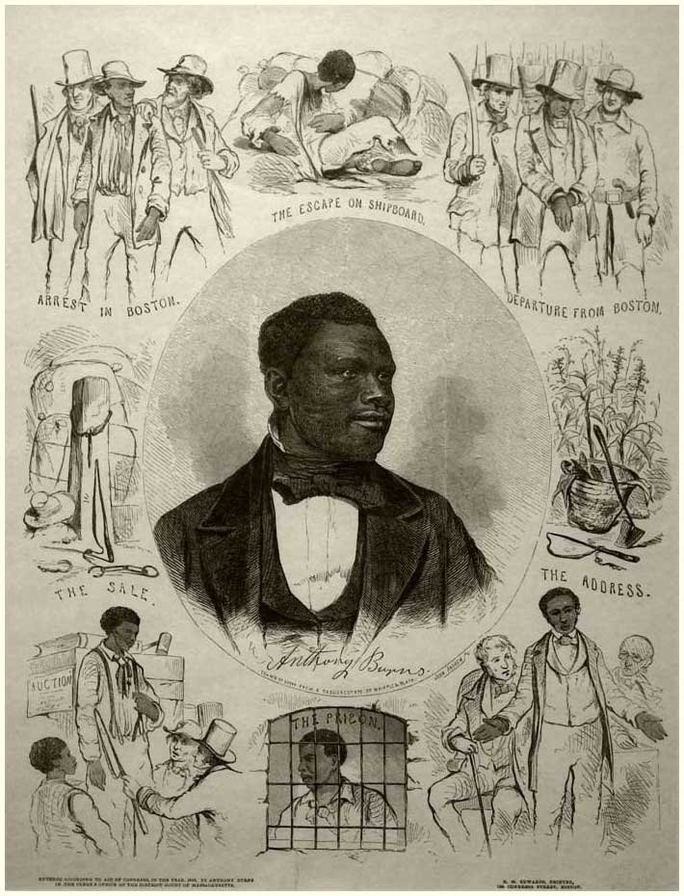
Image: R.M. Edwards. Anthony Burns. Broadside. Boston, 1855. Library of Congress, Prints and Photographs Division.

DISCUSSION QUESTIONS: Spend a few minutes examining the image.
1.Who does this image depict? What story is “told”?

2. If you aren’t already familiar with Anthony Burns’ story, what can you determine from this image?

3. What makes this image powerful? Which is scene is most powerful and why?

4. Who is the audience for this image/for the speech (pro slavery/abolitionist)? Why does audience matter?

5. What other types of primary sources could you search for to research this story?

6. How do you think fugitive slaves had an impact on the development of the anti-slavery movement?

