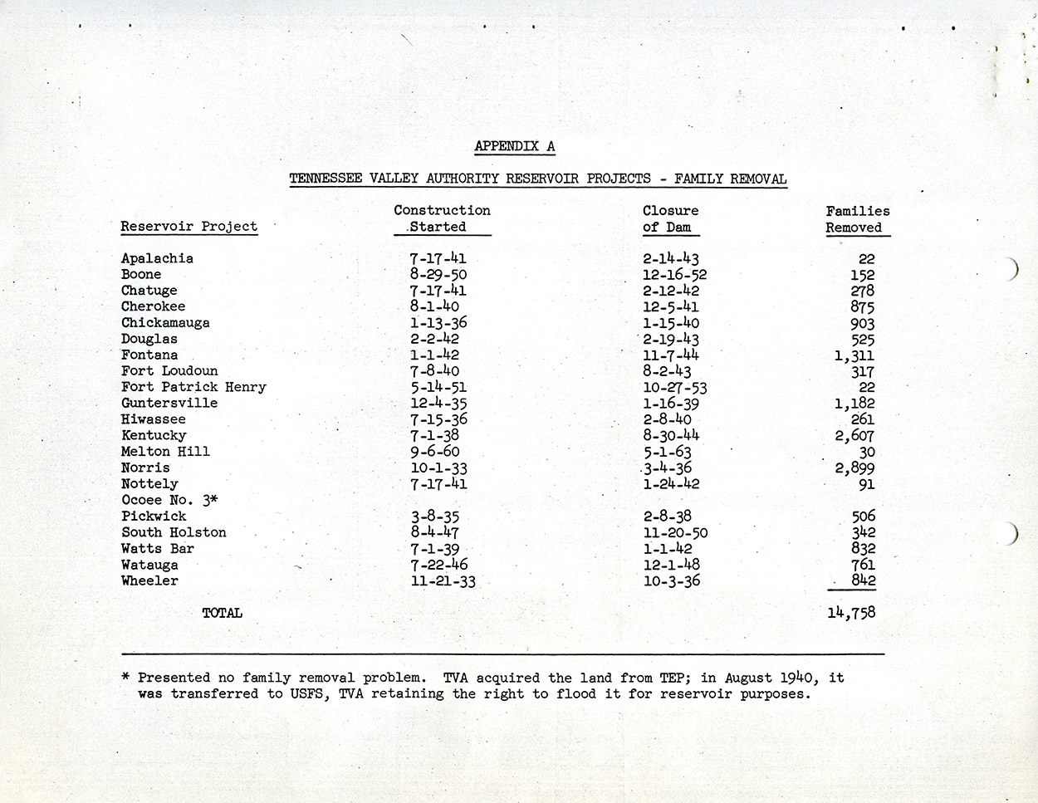

Source: Records of the Tennessee Valley Authority, Records Group Number 142, National Archives, Atlanta, National Archives Identifier 7130521

http://www.archives.gov/atlanta/exhibits/item342.html