Rosie the Riveter Activity
Standards:5.56, US.66
ROSIE THE RIVETER
During World War II, women responded to the call to work differently depending on age, race, class, marital status, and number of children. Half of the women who took war jobs were minority and lower-class women, who were already in the workforce. They switched from lower-paying traditionally female jobs to higher-paying factory jobs. The war effort required more workers, so high school graduates were recruited, as it was difficult to recruit married women because many of their husbands did not want them to work. The government also feared that a rise in working mothers would lead to a rise in juvenile delinquency. Eventually, the demands of the labor market were so severe that even women with children under 6 years old took jobs.

While patriotism did influence women, ultimately it was the economic incentives that convinced them to work. Once at work, they discovered the nonmaterial benefits of working like learning new skills, contributing to the public good, and proving themselves in jobs once thought of as only men’s work. While the image of the woman worker was important during the war, the prewar image of women as wives and mothers by no means disappeared. Mainstream society accepted temporary changes brought about by a war, but considered them undesirable on a permanent basis. The public reminded women that their greatest asset was their ability to take care of their homes and also that career women would not find husbands. After the war, the cultural division of labor by sex reasserted itself. Many women remained in the workforce but employers forced them back into lower-paying female jobs. Most women were laid off and told to go back to their homes.

While women worked in a variety of positions previously closed to them during World War II, the aviation industry saw the greatest increase in female workers. More than 310,000 women worked in the U.S. aircraft industry in 1943, making up 65 percent of the industry's total workforce (compared to just 1 percent in the pre-war years). The munitions industry also heavily recruited women workers, as illustrated by the U.S. government’s “Rosie the Riveter” propaganda campaign. Based in small part on a real-life munitions worker, but primarily a fictitious character, the strong, bandanna-clad Rosie became one of the most successful recruitment tools in American history, and the most iconic image of working women in the World War II era.
[Source http://www.nps.gov/pwro/collection/website/rosie.htm]

“Rosie the Riveter,”
written by Redd Evans and John Jacob Loeb

While other girls attend their fav’rite cocktail bar
Sipping Martinis, munching caviar
There’s a girl who’s really putting them to shame
Rosie is her name
All the day long whether rain or shine
She’s a part of the assembly line
She’s making history, working for victory
Rosie the Riveter
Keeps a sharp lookout for sabotage
Sitting up there on the fuselage
That little frail can do more than a male will do
Rosie the Riveter

Rosie’s got a boyfriend, Charlie
Charlie, he’s a Marine
Rosie is protecting Charlie
Working overtime on the riveting machine
When they gave her a production “E”
She was as proud as a girl could be
There’s something true about
Red, white, and blue about
Rosie the Riveter
Everyone stops to admire the scene
Rosie at work on the B-Nineteen
She’s never twittery, nervous or jittery
Rosie the Riveter
What if she’s smeared full of oil and grease
Doing her bit for the old Lendlease
She keeps the gang around
They love to hang around
Rosie the Riveter
Rosie buys a lot of war bonds
That girl really has sense
Wishes she could purchase more bonds
Putting all her cash into national defense
Senator Jones who is “in the know”
Shouted these words on the radio
Berlin will hear about
Moscow will cheer about
Rosie the Riveter!
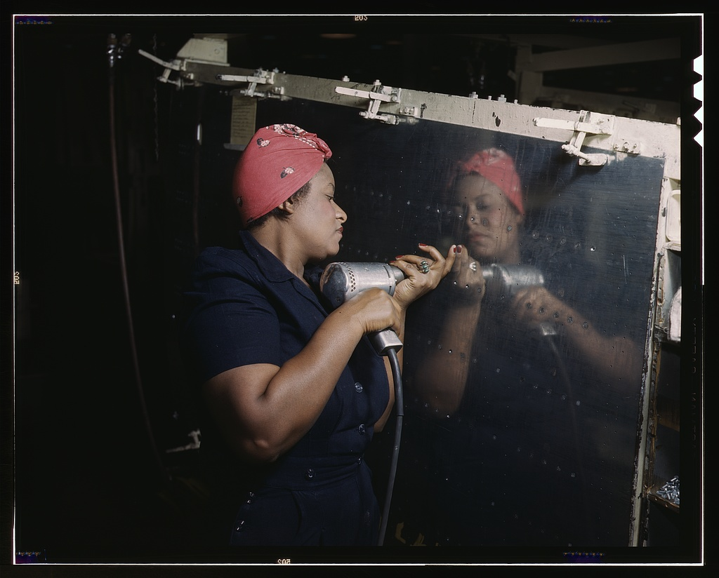
Palmer, Alfred T., photographer. “Operating a hand drill at Vultee-Nashville, woman is working on a "Vengeance" dive bomber, Tennessee.” From the Library of Congress Farm Security Administration - Office of War Information Collection. http://www.loc.gov/pictures/item/fsa1992001211/PP/.

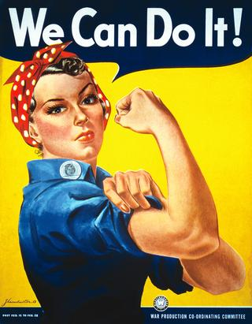

While the image on the front is today’s iconic “Rosie the Riveter” image, in the 1940s, it was a 1942 Westinghouse power company advertisement that was the prototype of the more popular (at the time) “Rosie” done by Norman Rockwell for the cover of the Saturday Evening Post. This Rosie image includes a flag and a copy of Adolf Hitler’s Mein Kampf under her feet.
Early in World War II, the United States government was not satisfied with women’s response to the call to work. The government decided to launch a propaganda campaign to sell the importance of the war effort and to lure women into working. They promoted the fictional character of “Rosie the Riveter” as the ideal woman worker: loyal, efficient, patriotic, and pretty. This song, entitled “Rosie the Riveter,” written by Redd Evans and John Jacob Loeb, became very popular in 1942.

DISCUSSION QUESTIONS: Spend a few minutes examining the poster on the front and the photograph above.

1. What descriptive words could be used to describe this poster (and photograph?)

2. What is different between the poster and the photograph? What is the same?

3. Is this poster and photograph of the Vultee woman patriotic? Why or why not? Does it make the job seem glamorous?

4. Do you think the poster of “Rosie the Riveter” is based on a real person or simply invented?

5. What does “Rosie the Riveter” symbolize, signify, or represent?

6. Do you think “Rosie the Riveter” is a positive character? How so?
Why is it important to show women in these roles?

