Tennessee and the Revolutionary War Activity
Standards:4.25, 4.34, 8.21, 8.25, 8.26
The Watauga Petition, 1776 Excerpts from the Watauga Petition, 1776 [Petition of the Inhabitants of Washington District, Including the River Watauga, Nonachuckie, & C.]
The [Watauga] purchase [March 19, 1775] was no sooner made, than we were alarmed by the reports of the present unhappy situation between Great Britain and America, on which report, (taking the new united colonies for our guide,) we proceeded to choose a committee, which was done unanimously by the consent of the people. This committee (willing to become a party in the present unhappy contest) resolved…to adhere strictly to the rules and orders of the Continental Congress, and in open committee acknowledged themselves indebted to the united colonies their full portion of the continental expense….

We shall now submit the whole to your candid and impartial judgment. We pray your mature and deliberate consideration in our behalf, that you may annex us to your Province, (whether as County, district, or other division,) in such manner as may enable us to share in the glorious cause of Liberty….

The effect of the Wataugans’ petition was that British representatives to the Cherokee began fueling fires of upset and frustration existing among some groups like Dragging Canoe’s Chickamaugas. Dragging Canoe had promised to fight against the growth of white settlement further into Cherokee territory. The resulting Cherokee Wars of 1776 (followed by attacks on both sides for a number of years after), turn the attention of the Overmountain Men of the Watauga and other frontier counties of Virginia and North Carolina (who annexed the Washington District in 1777 as a result of the Watauga Petition above) away from the eastern front of the Revolutionary War and the British toward the west in order to defend their homes from Cherokee attack.

We reached the Holston in the spring of that year [1776], and found the inhabitants busily preparing for troubles from the Indians. They were forting up all along the frontier and the men were organized into companies under various officers.—John Wheeler, from his Revolutionary War Pension Application

1780 brought a new threat. British Colonel Patrick Ferguson demanded allegiance to the King from the residents or he threatened to march across the mountains and destroy their homes by “fire and sword.” This message was received by militia generals Isaac Shelby and John Sevier, as well as those men who had been fighting the Cherokee in defense of their homes already. The Overmountain Men now turned their attention from the west to the east, and they prepared to meet Colonel Ferguson before he could reach their settlements. More than 1,000 men gathered at the Sycamore Shoals along the Watauga River in order to prepare for their expedition into the mountains. They did not realize as they came together that they would soon meet Colonel Ferguson and the Tories he led at a place called Kings Mountain in South Carolina. They also didn’t know then that they would be successful in defeating the colonel and disbanding his troops. Tory soldiers would never successfully serve against patriots in the South after this defeat.

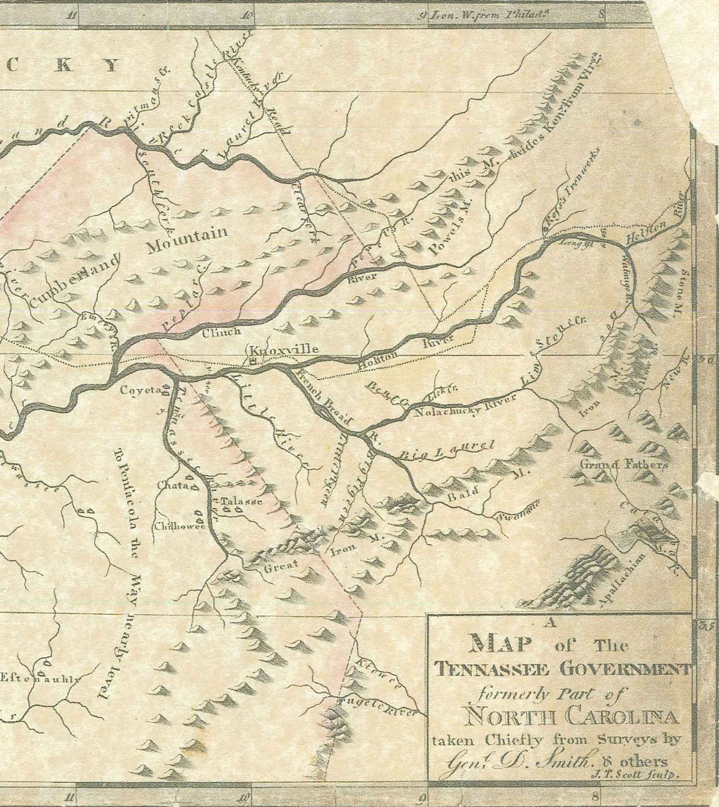
Source: A map of the Tennassee government, formerly part of North Carolina, taken chiefly from surveys by Gen. D. Smith & others c. 1794-1795. From North Carolina Maps Project, http://www2.lib.unc.edu/dc/ncmaps/

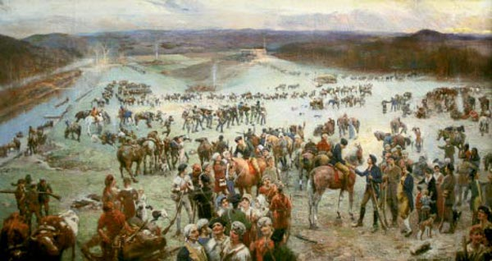
Artist Historian—Lloyd Branson (1854-1925) Lloyd Branson grew up around Maynardville in Union County, Tennessee. After becoming a professional artist in Knoxville, he completed the “Gathering at Sycamore Shoals” painting in 1915. Known for his “historical tableaux” or paintings of historical events and people, this is a perfect example of where Branson’s love for and study of the state’s early history was expressed through his talent. Instead of writing about history, he chose to paint it! How would you choose to communicate what you have learned about our state and nation’s history?

What Do You See?
Study the people in the painting.
What types of people are present at Sycamore Shoals? What are they saying to each other?
Choose one group of people to describe as well as give words to the conversation they are having in writing.
Study the map. Find the Watauga River in the eastern corner of the map. Would all of the people gathering at Sycamore Shoals be from that community, or are there other rivers on the map that would have served as home for frontier communities? If there were other settlements, why did everyone gather at Sycamore Shoals? Look at the painting to see if you can find evidence to justify whey they would meet at that location.
Find the towns of Chota, Talasse, and Chilhowee along the Tennessee River (look to the south west from the Watauga River). Who do you think lived in these towns? Settlers or Cherokee? Why?

